B.Vaishnavi -2303A51657 ASSIGNMENT-8.1

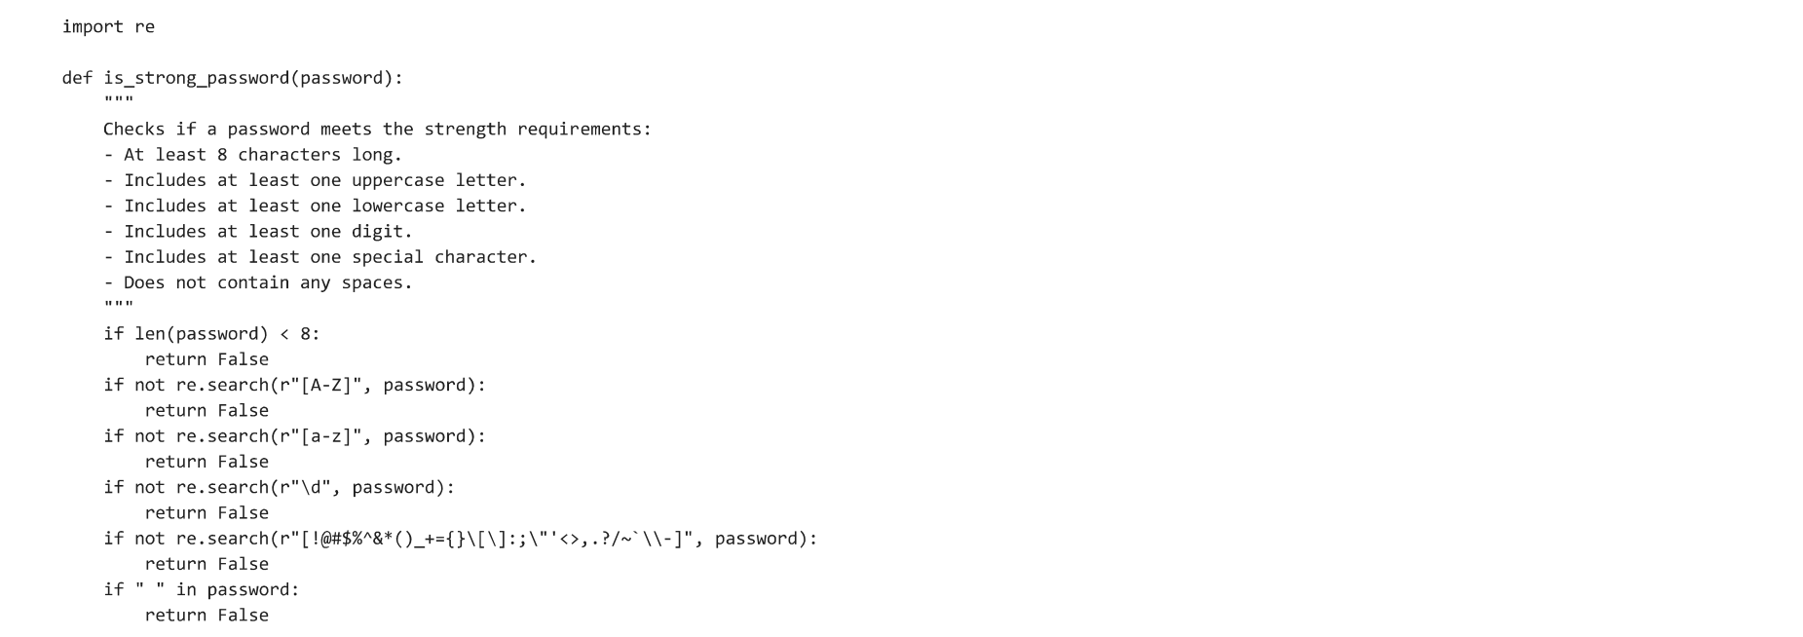

TASK

